**LAPORAN PRAKTIKUM ALGORITMA DAN PEMROGRAMAN KOMPUTER**

Laporan ini disusun untuk memenuhi Tugas Mata Kuliah

Praktikum Basis Data

Disusun Oleh :

AHSAN MAULANA RIZQI

104062400071

S1 BD-04-B

**PROGRAM STUDI S1 BISNIS DIGITAL**

**TELKOM UNIVERSITY PURWOKERTO**

**2025**

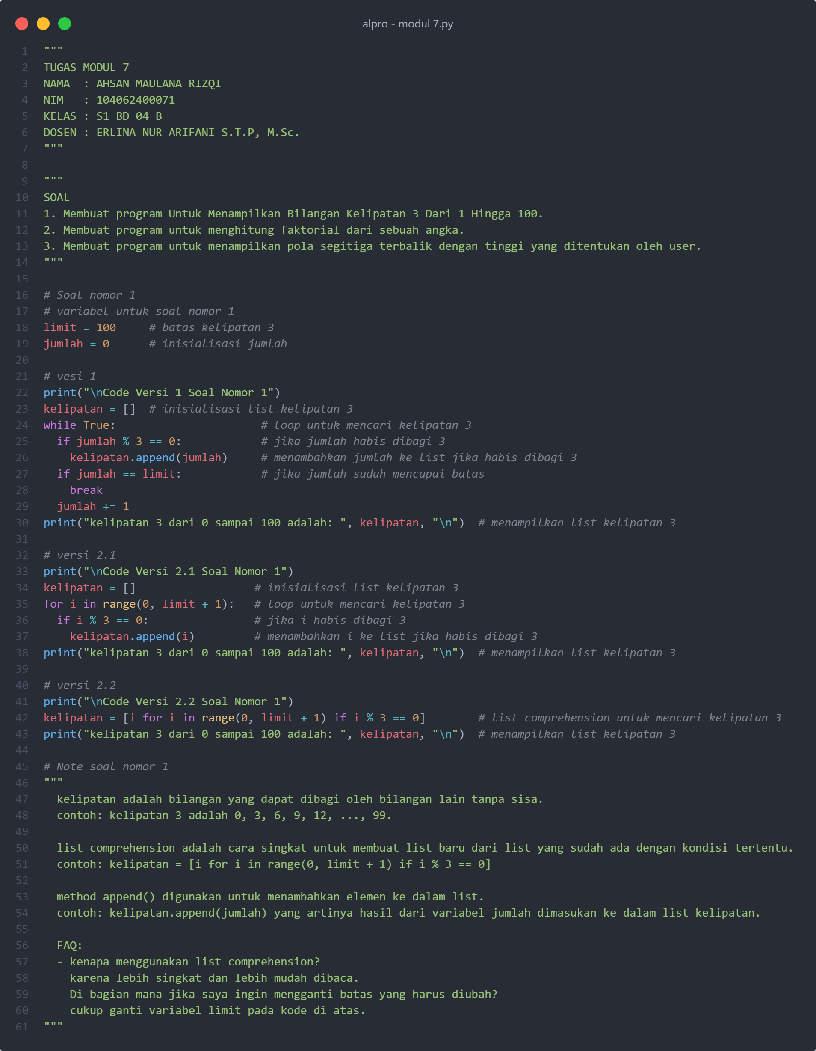

*Gambar 1. Source Code Bagian 1*

*Gambar 1. Source Code Bagian 2*

1. **Program Untuk Menampilkan Bilangan Kelipatan 3 Dari 1 Hingga 100**
   1. Setup Variabel

*Gambar 3. Inisialisasi Variabel Tugas 1*

* 1. *Main Program Atau Program Utama*

*Gambar 4. Main Program Tugas 1 Versi 1*

*Gambar 5. Main Program Tugas 1 Versi 2.1*

*Gambar 6. Main Program Tugas 1 Versi 2.2*

* 1. *Hasil Output*

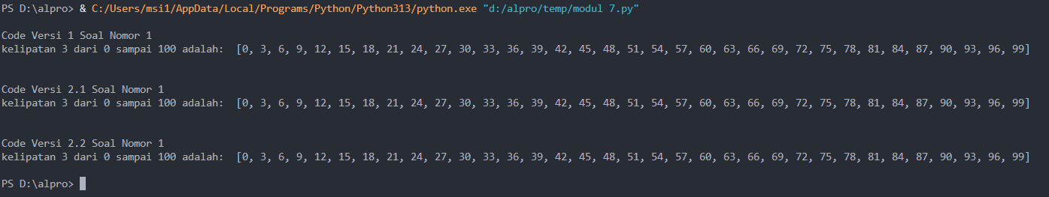

*Gambar 7. Hasil Output Dari Main Program Tugas 1*

1. **Program Untuk Menghitung Faktorial Dari Sebuah Angka**
   1. Setup Variabel

*Gambar 8. Inisialisasi Variabel Tugas 2*

* 1. *Main Program Atau Program Utama*

*Gambar 9. Main Program Tugas 2 Versi 1*

*Gambar 10. Main Program Tugas 2 Versi 2*

* 1. *Hasil Output*

*Gambar 11. Hasil Output Dari Main Program Tugas 2*

1. **Program Untuk Segitiga Terbalik Dari Bintang Berdasarkan Input Dari Pengguna**
   1. Setup Variabel

*Gambar 12. Inisialisasi Variabel Tugas 3*

* 1. *Main Program Atau Program Utama*

*Gambar 13. Main Program Tugas 3 Versi 1*

*Gambar 14. Main Program Tugas 3 Versi 2*

* 1. *Hasil Output*

*Gambar 15. Hasil Output Dari Main Program Tugas 3*